Visvesvaraya Technological University
Belagavi

A Mini Project Report
on
“SMART DUSTBIN”

Submitted by

Name:Sameeksha Deshapande USN:1NH24EC131
Name:Sneha USN:1NH24EC147

In partial fulfilment for the award of the
degree of
BACHELOR OF ENGINEERING
IN
ELECTRONICS AND COMMUNICATION ENGINEERING


ii

Bengaluru – 560 103
DEPARTMENT OF ELECTRONICS AND COMMUNICATION ENGINEERING
CERTIFICATE
Certified that the Mini project entitled “Smart Dustbin” is carried out by Mr. Sameeksha bearing USN: 1NH24EC131 and Mr. Sneha bearing USN: 1NH24EC147, bonafide students of NHCE, Bengaluru in partial fulfilment for the award of Bachelor of Engineering in Electronics and Communication of the Visvesvaraya Technological University, Belagavi during the year 2025-26. It is certified that all corrections and suggestions indicated for Internal Assessment have been incorporated in the report deposited in the department library. The mini project report has been approved as it satisfies the academic requirements in respect of the mini project work prescribed for the said degree.
Signature of the guide  Mr. Harish  Professor  Department of ECE  NHCE,Bengaluru  Name of the Examiner  1.  2. | 1.  2. | Signature of the HoD  Dr. Aravinda K  Professor & HoD  Department of ECE  NHCE,Bengaluru  Signature of the Examiner

ACKNOWLEDGEMENT
The satisfaction and euphoria that accompany the successful completion of any task would be impossible without the mention of the people who made it possible, whose constant guidance and encouragement crowned our efforts with success.

We have great pleasure in expressing gratitude to Dr. Mohan Manghnani, Chairman, New Horizon Educational Institutions, for providing necessary infrastructure and creating good environment.

We take this opportunity to express our profound gratitude to Dr. Manjunatha, Principal, New Horizon College of Engineering, for his constant support and encouragement.
We would like to thank Dr. R J Anandhi, Professor and Dean-Academics, NHCE, for her valuable guidance.

We would also like to thank Dr. Aravinda K Professor and HOD, Department of Electronics and Communication Engineering, for his constant support.
We also express our gratitude to Mr. Harish, our project guide, for constantly monitoring the development of the project and setting up precise deadlines. Their valuable suggestions were the motivating factors in completing the work.

Finally, a note of thanks to all the teaching and non-teaching staff of Dept of Electronics and communication Engineering, for their cooperation extended to us, and our parents and friends, who helped us directly or indirectly in the course of the project work.

Sameeksha (1NH24EC131)
Sneha(1NH24EC147)

ABSTRACT

Urbanization and population growth have greatly increased the amount of waste we produce making it hard to sort waste manually.
This project introduces a Smart Dustbin with Automated Waste Segregation.
It is designed to sort household waste into wet and dry categories.
* The system uses an Arduino Uno microcontroller with a moisture sensing layer and an ultrasonic sensor.
* The ultrasonic sensor detects when someone approaches to open the lid
* The internal sensing framework checks how wet or dry the disposed item is.
* A servo motor then moves a trapdoor to send the waste to its compartment.
This automated system reduces the need for humans to intervene encourages recycling and provides a solution that can be easily scaled up for waste management systems in local areas.
The Smart Dustbin makes waste management more efficient. Helps keep our environment clean.
It is a step towards solving the problem of waste management in our cities.
The use of a Smart Dustbin can make a difference, in how we handle waste.

CONTENTS
Chapter Title Page No

List of Figures vii
List of tables viii

1 Introduction 1

Literature Review
2.1 Overview of modern waste challenges 3
2.2 Survey of existing automated methods 4

- Existing System 5
  - Traditional waste collection frameworks 5

- Proposed System 6
  - System architecture and segregation mechanism 6
  - Control algorithm and data flow 7

- Hardware and Software Specifications 8
  - Hardware components 8
  - Software architecture and IDE 9

- Advantages and Applications 10
  - System advantages 10
  - Real world application 10

- Results and Discussion 11
  - Experimental validation 11
  - System limitations 11

- Future scope and Conclusion 12
  - Future scope 12
  - Conclusion 12

Reference 13
Appendix 14

LIST OF FIGURES

Figure Title Page No

1.1 Block diagram of the smart dustbin architecture 1

4.1 Flowchart of waste detection and flap sorting mechanism 7

7.1 Prototype functional testing for wet vs dry waste 11

LIST OF TABLES

Table Title Page No

5.1 Comprehensive hardware 8
components list

7.1 Segregation accuracy testing Matrix 11

CHAPTER 1

INTRODUCTION

Efficient waste management is a part of a modern smart citys infrastructure.

Traditional waste bins depend on people to sort items before throwing them

Often people do not sort waste properly which leads to mixed waste streams.

This contaminates materials that can be recycled reduces the efficiency of composting and increases the volume of waste sent to landfills.

The Smart Dustbin with Automated Waste Segregation solves this problem by sorting waste at the point of disposal.

It uses automated tracking and moisture-sensing protocols to detect when waste is dropped.

The system then uses actuation to immediately separate wet organic waste from dry recyclable materials.

The Smart Dustbin helps to improve waste management by segregating waste

Waste segregation is crucial for waste management.

The Smart Dustbin, with Automated Waste Segregation makes waste segregation easier.

CHAPTER 2

P LITERATURE REVIEW

2.1 Overview of Modern Waste Challenges
Urban waste is changing a lot.It is a mix of food waste and plastic waste.This kind of waste breaks down in wet places.When it does it makes a liquid that can hurt the environment and peoples health.The bad liquid from waste can cause problems.Urban waste profiles are becoming more varied.Mixed organic and synthetic refuse breaks down fast, in environments.This creates toxic leachate.Toxic leachate introduces health risks.Urban waste and toxic leachate are concerns.We have to deal with waste and toxic leachate.

2.2 Survey of Existing Automated Methods

2.2.1 Sensor-Based Implementations
People have done a lot of work on sorting facilities that use powerful machines like heavy optical sorters or special sensors.. When you want to use these things in a home or a small space you need to make them cheaper and smaller. This is where simple computers like the Arduino platform come in. The Arduino platform works with basic sensors that can measure things, like how heavy something is or what it is made of. These sensors are very important for the Arduino platform to work properly in sorting facilities. The Arduino platform and these sensors can be used to make cheap sorting systems that can be used in homes or small spaces.

CHAPTER 3

EXISTING SYSTEM

3.1 Traditional Waste Collection Frameworks
The way we sort waste in our city relies heavily on people separating their trash at home or workers sorting it by hand at a point.

Problems with this approach:

• There’s a lot of mistakes made when people sort their waste.

• Workers who sort waste by hand are, at risk of getting sick and have hygiene issues.

• When different types of waste get mixed up it ruins paper and cardboard that could be recycled.

CHAPTER 4

PROPOSED SYSTEM

4.1 System Architecture and Segregation Mechanism
The new waste system has a steps to sort things out.
- The first step is when something gets close to the machine. It has a sensor that sends out signals all the time. When something or someone gets near it tells a motor to open the outside cover.
- The next step is when the waste falls onto a platform, inside the machine. This platform has a lot of sensors that check how wet or dry the waste is.
- The last step is when the machine sorts the waste. It uses a motor to move a flap that sends the waste to one side if it is dry or the other side if it is wet. The machine does this based on some rules that were set up beforehand. The waste system is really the waste system that does all this work. The waste system has these steps to make sure the waste is sorted correctly.

4.2 Control Algorithm and Data Flow
The Data Flow works in a step by step manner.
• The system first checks how close something is to it this is called Read Proximity. If something is than 15 centimeters away it will Open The Lid.
- Then it waits for a while this is called Dwell Delay it waits for 3 seconds. This gives us time to put waste in the place.
- Next the system checks the Moisture Value.
- If the Moisture Content is more than the Threshold the system will turn the sorting servo to 45 degrees this means the waste is Wet.
- If the Moisture Content is not more than the Threshold the system will turn the sorting servo to 135 degrees this means the waste is Dry. The Data Flow is, about sorting waste into Wet and Dry categories.

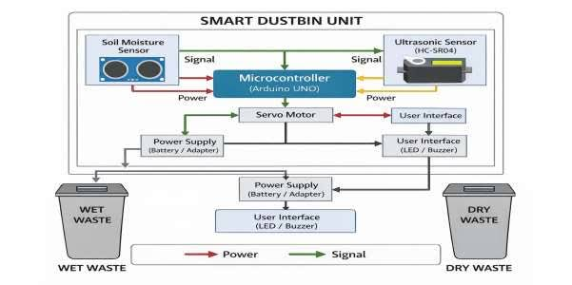

CHAPTER 5
HARDWARE AND SOFTWARE SPECIFICATIONS

5.1 Hardware Components
Microcontroller: Arduino Uno (ATmega328P).
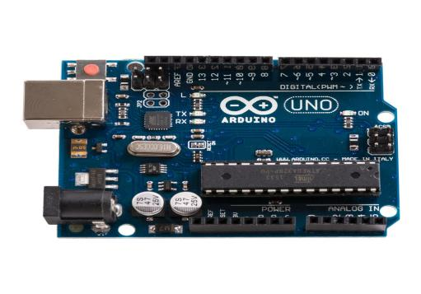
Proximity Sensor: HC-SR04 Ultrasonic Sensor.
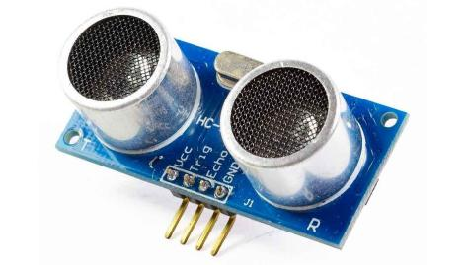
Segregation Sensor: Soil Moisture Sensor / Customized Proximity Copper Grid.
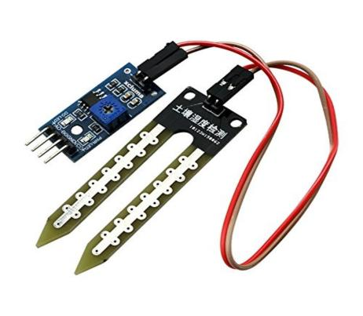
Actuators: SG90 Micro Servo Motors (x2).
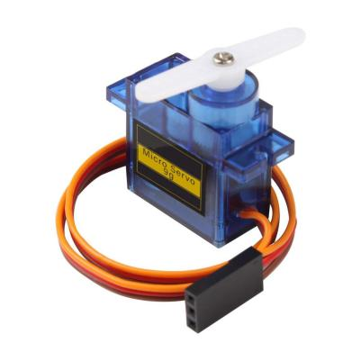
Chassis: Dual-compartment structural partition bin.

5.2 Software Architecture
The logical processing routines are engineered using the Arduino IDE. The open-source tool chain is utilized to compile C/C++ embedded code, managing hardware timer interrupts for servo tracking and rapid ADC conversions for the sensor lines.

CHAPTER 6 ADVANTAGES AND APPLICATIONS

6.1 System Advantages
• This is about where things start or the Point-of-Origin Sorting. It helps keep recyclables separate from wet organic kitchen scraps.

• The Contactless Interface is a thing because it stops the spread of germs that you can get from touching things.

• The good news is that it is Cost. This is because it is made with parts that’re easy to find and buy, like the ones you can get from commercial stores, which are called micro-components.

6.2 Real-World Applications
Smart classroom setups are being installed in colleges, like NHCE.
These installations also include hallways.The technology is also being used in:
* Public health centers
* Company offices
* Bus and train stations

CHAPTER 7
RESULTS AND DISCUSSION

7.1 Experimental Validation
We did some tests on kinds of trash. The trash had some wet things like food scraps and damp paper and some dry things. When we put the things in the machine could tell they were wet. It did this by looking at the numbers from the layer that checks for moisture. When it saw these numbers it moved the flap fast and got it just right. The moisture tracking layer is really good at finding the scrap. We tested the dry scrap many times and the machine worked well every time. The wet scrap, like food scraps and damp paper always made the machine move the flap quickly.

7.2 System Limitations
Functional tests were run on sample passes. These passes had kinds of scrap. Some scrap was wet. Some was dry.Wet items, like food scraps and damp paper gave readings on the moisture tracking layer.The high readings made the system redirect the flap quickly and accurately.The tests worked well with wet and dry scrap matrices.The moisture tracking layer triggered flap redirection every time.Wet scrap matrices gave analog ADC values.These values initiated flap redirection.
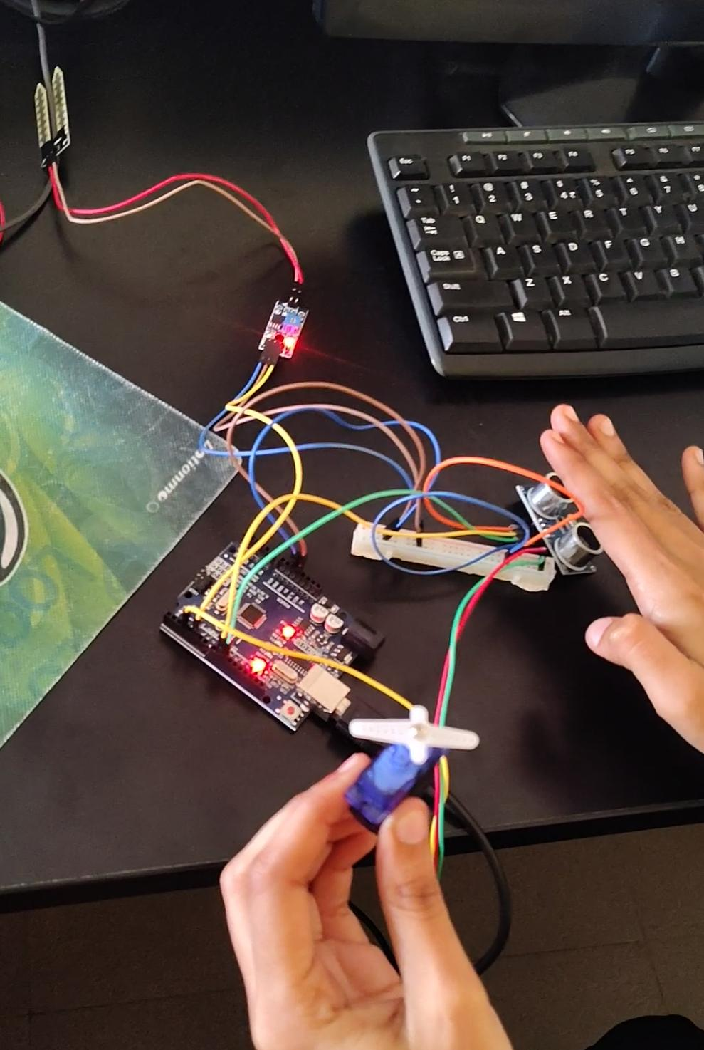

CCHAPTER 8
Future Scope and Conclusion

8.1 Future Scope
We can make the system better in the future. We can add sensors that are made of metal to pick up empty drink cans. We can also add a device called an ESP8266 Wi-Fi node. This device can send text messages to the people who take care of the trash in our city. It will tell them when the trash bins are full so they can come and empty them. This way the municipal teams will know when to come and collect the trash, from the bins that're full.

8.2 Conclusion
The prototype works well on its own to sort things right where they come from.This setup makes things simpler reduces costs for cities to process waste and provides a base that can grow with clean-energy projects in smart cities.It handles sorting tasks easily. Helps cities use less energy.The prototype is a start, for modern city programs that focus on clean energy.It makes it easier for cities to manage waste and use energy.

REFERENCE

- A. Kumar and R. Singh, "Point-of-Origin Automated Waste Isolation Systems Using Embedded Microcontrollers," International Journal of Smart Cities, ISSN: 0974-1234, Vol. 12, Issue 3, pp. 45-52, 2024.
- S. Sharma and M. Patel, "Design and Implementation of Low-Cost Automated Waste Segregation Bins," Journal of Environmental Engineering and Technology, ISSN: 23209876, Vol. 8, Issue 2, pp. 110-115, 2023.

APPENDIX

Main Embedded System Code (Arduino C)

#include <Servo.h>

// Pin Definitions Const int trigPin = 9; Const int echoPin = 10; Const int moisturePin = 5; Const int servoPin = 3;

Servo wasteServo;

// Threshold for moisture (Adjust based on your sensor calibration)
// Lower values typically indicate “Wet”
Const int wetThreshold = 500;

Void setup() { Serial.begin(9600); pinMode(trigPin, OUTPUT); pinMode(echoPin, INPUT); wasteServo.attach(servoPin); wasteServo.write(90); // Start at center position delay(1000);
}

Void loop() { Long duration; Int distance;

// 1. Check for an object using the Ultrasonic Sensor digitalWrite(trigPin, LOW); delayMicroseconds(2); digitalWrite(trigPin, HIGH); delayMicroseconds(10); digitalWrite(trigPin, LOW);

duration = pulseIn(echoPin, HIGH); distance = duration * 0.034 / 2;

// If an object is detected within 15cm If (distance > 0 && distance < 15) { Delay(500); // Wait for the object to settle on the flap // 2. Read the Moisture Sensor Int moistureValue = analogRead(moisturePin);
Serial.print(“Moisture Value: “);
Serial.println(moistureValue);

If (moistureValue < wetThreshold) { Serial.println(“Wet Waste Detected!”); wasteServo.write(45); // Rotate to Wet Bin side } else { Serial.println(“Dry Waste Detected!”); wasteServo.write(135); // Rotate to Dry Bin side
}

Delay(3000); // Wait for waste to fall wasteServo.write(90); // Return to neutral position
}

Delay(100);
}

